

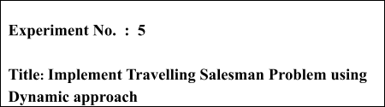

# Batch: B2 Roll No.: 16010421119 Experiment No.: 5

**Aim:** To Implement Travelling Salesman Problem for minimum 6 vertices using Dynamic approach and analyse its time Complexity.



# Algorithm of Travelling Salesman Problem:

**Algorithm: Traveling-Salesman-Problem**

C ({1}, 1) = 0

for s = 2 to n do

for all subsets S Є {1, 2, 3, … , n} of size s and containing 1 C (S, 1) = ∞

for all j Є S and j ≠ 1

C (S, j) = min {C (S – {j}, i) + d(i, j) for i Є S and i ≠ j}

Return minj C ({1, 2, 3, …, n}, j) + d(j, i)

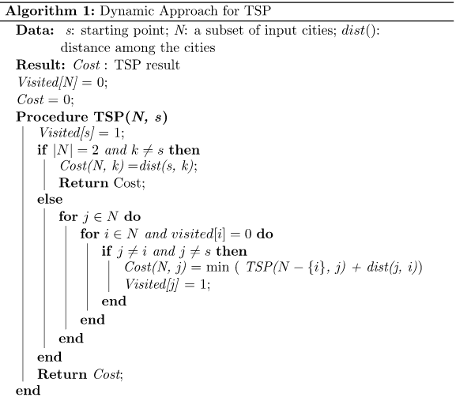

# Explanation and Working of Travelling Salesman Problem:

**Problem Statement**

A traveller needs to visit all the cities from a list, where distances between all the cities are known and each city should be visited just once. What is the shortest possible route that he visits each city exactly once and returns to the origin city?

# Solution

Travelling salesman problem is the most notorious computational problem. We can use brute-force approach to evaluate every possible tour and select the best one. For n number of vertices in a graph, there are (n - 1)! number of possibilities.

Instead of brute-force using dynamic programming approach, the solution can be obtained in lesser time, though there is no polynomial time algorithm.

Let us consider a graph G = (V, E), where V is a set of cities and E is a set of weighted edges. An edge e(u, v) represents that vertices u and v are connected. Distance between vertex u and v is d(u, v), which should be non-negative.

Suppose we have started at city 1 and after visiting some cities now we are in city j. Hence, this is a partial tour. We certainly need to know j, since this will determine which cities are most convenient to visit next. We also need to know all the cities visited so far, so that we don't repeat any of them. Hence, this is an appropriate sub-problem.

For a subset of cities S Є {1, 2, 3, ... , n} that includes 1, and j Є S, let C(S, j) be the length of the shortest path visiting each node in S exactly once, starting at 1 and ending at j.

When |S| > 1, we define C(S, 1) = 𝖺 since the path cannot start and end at 1.

Now, let express C(S, j) in terms of smaller sub-problems. We need to start at 1 and end at j. We should select the next city in such a way that

C(S,j)=minC(S−{j},i)+d(i,j)wherei∈Sandi≠jc(S,j)=minC(s−{j},i)+d(i,j)wherei∈Sandi≠j

# Example

In the following example, we will illustrate the steps to solve the travelling salesman problem.

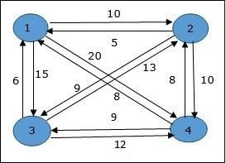

From the above graph, the following table is prepared.

|  |  |  |  |  |
| --- | --- | --- | --- | --- |
|  | 1 | 2 | 3 | 4 |
| 1 | 0 | 10 | 15 | 20 |
| 2 | 5 | 0 | 9 | 10 |
| 3 | 6 | 13 | 0 | 12 |
| 4 | 8 | 8 | 9 | 0 |

The minimum cost path is 35.

Start from cost **{1, {2, 3, 4}, 1}**, we get the minimum value for **d [1, 2]**. When **s = 3**, select the path from 1 to 2 (cost is 10) then go backwards. When **s = 2**, we get the minimum value for **d [4, 2]**. Select the path from 2 to 4 (cost is 10) then go backwards.

When **s = 1**, we get the minimum value for **d [4, 3]**. Selecting path 4 to 3 (cost is 9), then we shall go to then go to **s = Φ** step. We get the minimum value for **d [3, 1]** (cost is 6).



# Derivation of Travelling Salesman Problem:

Time complexity Analysis

Algorithm: Traveling-Salesman-Problem C ({1}, 1) = 0

for s = 2 to n do

for all subsets S Є {1, 2, 3, … , n} of size s and containing 1 C (S, 1) = ∞

for all j Є S and j ≠ 1

C (S, j) = min {C (S – {j}, i) + d(i, j) for i Є S and i ≠ j}

Return minj C ({1, 2, 3, …, n}, j) + d(j, i) Analysis:

There are at the most 2n.n sub-problems and each one takes linear time to solve. Therefore, the total running time is O(2n.n2).

# Program(s) of Travelling Salesman Problem:

#*include* <bits/stdc++.h> #*define* int long long using namespace std;

int travellingSalesman(vector<vector<int>> graph, int s)

{

vector<int> vertex;

*for* (int i = 0; i < graph.size(); i++)

{

*if* (i != s)

vertex.push_back(i);

}

// *for(int i=0;i<vertex.size();i++)cout<<vertex[i]<<" ";*

int min_path = LONG_LONG_MAX;

*do*

{

int current_weight = 0; int k = s;

*for* (int i = 0; i < vertex.size(); i++)

{

current_weight += graph[k][vertex[i]]; k = vertex[i];

}

current_weight += graph[k][s];

min_path = min(min_path, current_weight);

} *while* (

next_permutation(vertex.begin(), vertex.end()));

*return* min_path;

}

int32_t main()

{

ios_base::sync_with_stdio(false); cin.tie(NULL);

#*ifndef* ONLINE_JUDGE freopen("input.txt", "r", stdin);

freopen("output.txt", "w", stdout); #*endif*

int n; cin >> n;

vector<vector<int>> v(n, vector<int>(n));

*for* (int i = 0; i < n; i++)

{

*for* (int j = 0; j < n; j++)

{

cin >> v[i][j];

}

}

cout << "Minimum Distance- " << travellingSalesman(v, 0);

}

# Output(o) of Travelling Salesman Problem:



**Post Lab Questions:- Explain how Travelling Salesman Problem using greedy method is different from Dynamic Method in detail.**

The Greedy Method starts by selecting a starting city and then selecting the closest unvisited city as the next stop. This process is repeated until all cities have been visited, and the salesman returns to the starting city. While this method is relatively simple and fast, it does not guarantee an optimal solution. In some cases, the Greedy Method may find a solution that is far from the optimal one.

The Dynamic Method, on the other hand, is a more complex algorithm that seeks to solve the TSP by breaking it down into smaller subproblems. The algorithm first considers the smallest subproblems (i.e., visiting only two cities) and then combines their solutions to build larger subproblems (i.e., visiting three cities, four cities, etc.). The Dynamic Method stores the solutions to each subproblem in a table, which can be used to compute the solution to larger subproblems efficiently. The algorithm continues to build up solutions to larger subproblems until it finds the optimal solution to the full TSP.

While the Dynamic Method is more complex than the Greedy Method, it is guaranteed to find the optimal solution to the TSP. However, the Dynamic Method is computationally expensive and may not be practical for larger TSP instances. The Greedy Method, while not guaranteed to find the optimal solution, is faster and more scalable, making it a practical solution for smaller TSP instances.



# Conclusion: (Based on the observations):

Travelling salesman problem is successfully understood



**Outcome:** CO2 Implement Greedy and Dynamic Programming algorithms



# References:

1. Richard E. Neapolitan, " Foundation of Algorithms ", 5th Edition 2016, Jones & Bartlett Students Edition
2. Harsh Bhasin , " Algorithms : Design & Analysis", 1st Edition 2013, Oxford Higher education, India
3. T.H. Coreman ,C.E. Leiserson,R.L. Rivest, and C. Stein, " Introduction to algorithms", 3rd Edition 2009, Prentice Hall India Publication
4. Jon Kleinberg, Eva Tardos, " Algorithm Design", 10th Edition 2013, Pearson India Education Services Pvt. Ltd.